Granlahan N.S Student Friendly Bí Cineálta Policy ***Designed by The Student Council***

Bí Cineálta!

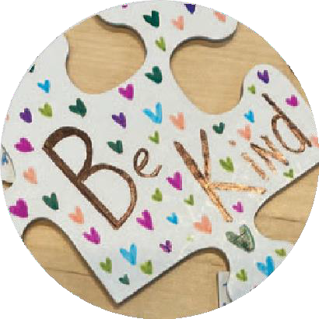

We want everyone at our school to feel safe and happy.

If you think that you are being bullied or someone else is being bullied, you need to tell a teacher or another adult that you trust. They will know what to do to help.

Get help! Tell someone!

Image 30

Remember your

Trusted 5

If a student tells a staﬀ member that they think they are being bullied, we will:

* talk with the student
* ask the student what they want to happen
* work out a plan together
* talk to their parents
* talk to the other student(s) involved
* talk with the other student’s parents

Bullying behaviour is when someone keeps being mean

or hurtful to others on purpose over and over again.

Please

tell someone if you think that you are being bullied or someone else is being bullied.

Targeted?

Repeated?

Hurtful?

Our school

has a Bí Cineálta policy to try to stop

bullying behaviour.

We look at this policy every year to see

what is working well or what could work

better. We will ask you what you

think.

Image 26

Image 16Image 13

When it happens a lot. Not just once.

# 

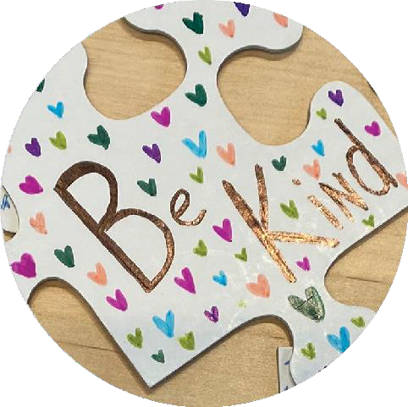

# Main Heading

## To get started, just tap or click this placeholder text and begin typing.

Use paragraph styles to give your document a consistent look. For example, this paragraph uses Body style. You can change it in the Text tab of the Format controls.