Policy for Religious Education

Diocesan Template for the Formulation of a Policy for Religious Education in Catholic Primary Schools

In the Archdiocese of Tuam

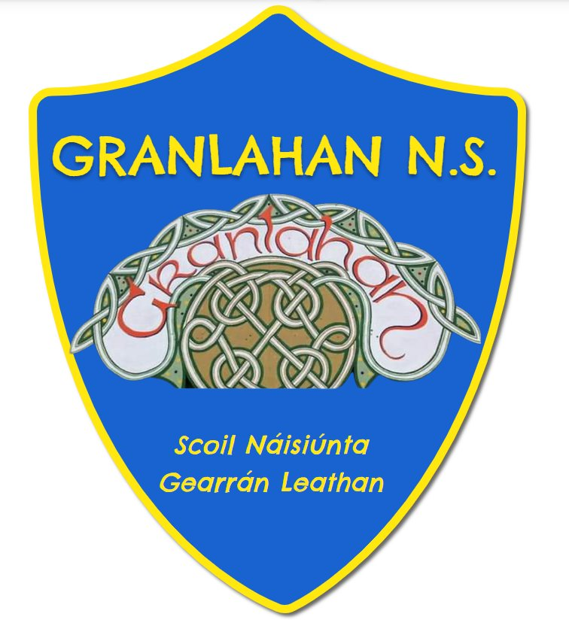

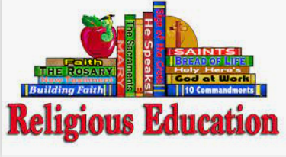
Religious Education Policy for
Catholic Schools in the archdiocese of Tuam

Introduction:
This policy has been formulated by the staff and board of management of Granlahan N.S. and ratified at a board meeting on the 12.12.2022

The Aim of Religious Education in a Catholic School
The aim of Religious Education is to help children mature in relation to their spiritual, moral and religious lives, through their encounter with, exploration and celebration of their Catholic faith.

The Vision for Religious Education in a Catholic Schools
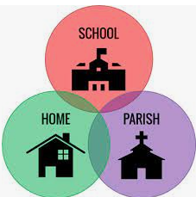
In the Irish context the educational vision of the Church is a pastoral one. It acknowledges the complementary, connected, but different roles of the home, school and parish community in the faith education of children.
In this vision, parents are the first and the primary teachers of their children in faith and the home is the first school of faith.
The parish is where children learn to worship, where they meet Jesus Christ in sacramental celebrations and where they experience and share in the mission of the Church.
Religious education in the Catholic primary school has two distinct but complementary dimensions; the educational dimension and the faith formation dimension.
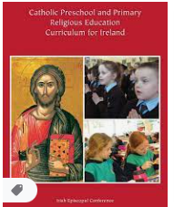
- The educational dimension is centred and founded on the formal curriculum and focuses on the values and teachings of the Catholic Church. It teaches children the skills of spiritual, moral and religious literacy. The Religious Education outcomes at each level in the curriculum reflect this dimension.
- The faith formation dimension forms the children’s characters in the virtues and values of Jesus, supports their faith development and helps them to experience what it means to be a member of the Church. The faith formation goals in the curriculum (pp 134-143) support and reflect this dimension.

An important part of this vision is our response to religious and cultural change in our society. Catholic schools are places where all are respected and valued. This includes the many different levels of faith that we will encounter in both our teachers and pupils and those pupils who are of other faiths and different stances for living.

Aim of Religious Education Policy
The purpose of this religious education policy is:

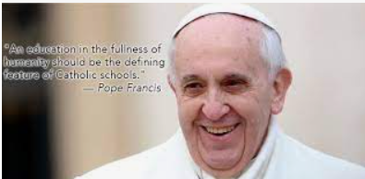
- To ensure that we strive to understand and promote religious education in a Catholic primary school as never simply one subject among many, but the foundation of the entire educational process.

- To ensure that formal teaching in matters of belief, values and practice that equip children for a free and intelligent expression of personal faith within the family, Church and wider society is provided. (based on Share the Good News 39).

- To appreciate the richness of all religious traditions, especially those present in our school community, and to provide a framework to encounter these traditions.

- To provide appropriate religious education for the different levels of faith commitment that we encounter in our classrooms.

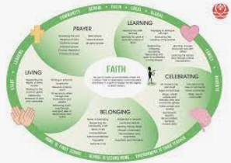
- To lead to a greater degree of clarity in respect of aims, procedures and roles for RE in the school.

- To assist all members of staff in the teaching of Religion.

- To consider strategies that respond to the needs of children of different faiths and other stances for living in terms of religious education.

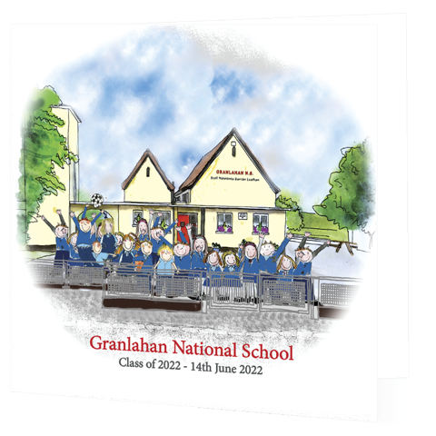

About our Catholic School:
Our school is a Catholic school under the patronage of the bishop of Tuam, Archbishop Francis Duffy. Our school is in the parish of Kiltullagh The priest(s) of the parish: Fr. Joe Feeney and Fr. Stephen Farragher

The chaplain: Fr. Joe Feeney and Fr. Stephen Farragher

The Religious Coordinator: Michelle Devine and Anne Marie Naughton.


The members of the Board of Management:
- Maureen Behan
- Fr. Joe Feeney
- Michelle Devine
- Anne-Marie Naughton
- Maura McCafferty
- Teresa Hebron
- Shane Keaveney
- Sean McGuire

School Environment

Visitors, parents and children know that we are a Catholic School:
- The Schedule for the Catholic School is on display and visible to all visitors to the school.
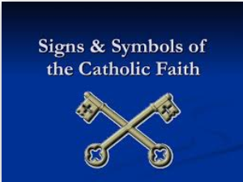
- The Mission Statement for our school has been developed, is included with all welcome information for parents and staff and is regularly reviewed.

- There are religious symbols and visible signs of our Catholic faith in all public areas of our school.

- There is a Prayer Space that reflects the liturgical seasons in the entrance area of our school.

- There is ongoing communication with the local priest or parish worker who acts as chaplain to the school. Regular meetings and visits are scheduled throughout the school year.
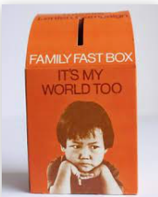
- Missionary awareness is highlighted through the school’s support and engagement with charities such as Trócaire, Concern, Children Helping Children and other agencies.

- Social justice awareness is highlighted through the school’s support and engagement with charities such as the Society of St. Vincent de Paul, Focus Ireland and other agencies.

Prayer in Our School
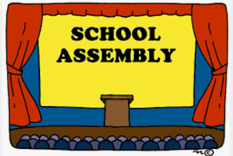
- Religiously themed assemblies, communal prayer time and liturgical celebrations are timetabled during the school year e.g. beginning of school year Mass, Graduation Mass, November Prayer Service, Advent and Lenten celebrations, Catholic Schools Week celebration, etc.

- Important Feast Days are celebrated throughout the Church Year.

- All meetings in the school begin and end with prayer.

- Staff are offered opportunities for prayerful reflection, retreat and personal faith development on a regular basis.

- There is time for prayer in every classroom at the beginning of the day, before and after lunch and before the children leave at home time.


- Children know their formal prayers and Mass responses as indicated by the curriculum; Level 1 p59; Level 2 page 74; Level 3 p 94; Level 4 page 120.

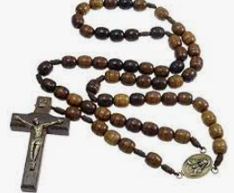
- The rosary is prayed with children at level 2, 3 and 4 as indicated by the curriculum.

- Children have the opportunity to experience different forms of prayer, e.g. meditation, contemplation, spontaneous prayer, Eucharistic Adoration

Timetabling and Teaching staff
Our school believes that religious education is a core subject in a Catholic primary school. It is the foundation of the entire educational process. This means that:

- Religious education is timetabled in each classroom for the designated time of 2 ½ hours per week.

- Religious education is included in all teachers Fortnightly Notes and Cúntas Míosuil.

- All teachers have a hardcopy or have access to the online copy of the Pre-School and Primary Religious Education Curriculum for Ireland.

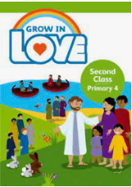
- All teachers have the relevant Grow in Love/I nGrá Dé materials needed to teach religious education in their classroom.

- The principal or Religious Education Coordinator distributes all resources and relevant communication from the Diocesan Advisor’s office.

- Opportunities for ongoing professional development are regularly offered to teachers.

Classroom Environment
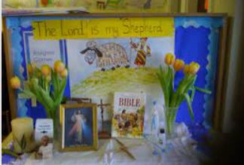
- There is a Prayer Space in every classroom. This space reflects the movement of the liturgical seasons. It also contains samples of the children’s work, religious symbols and God’s creation.
- Every Prayer Space has a Bible (Catholic Children’s Bible)
- There are symbols of the Catholic faith in every classroom e.g. a Holy Water Font, religious icon or picture, cross or crucifix, May altar, Crib, etc.

Classroom Teaching
In teaching the approved religious education programme for use in the diocese, teachers are enabling children to learn the skills of moral, spiritual and religious literacy so that their understanding of their Christian faith is constantly deepened and they develop a mature and informed response to God’s call to relationship. The skills of religious literacy as defined by the curriculum are understanding, communicating, participating, and added to these are the further skills of spiritual literacy and inter-religious literacy. (Curriculum page 35-37) The following will help ensure that this can be achieved

- All teachers have a recognised qualification in religious education

The following approved textbooks/workbooks are in use in the school (they alternate every other year):

Junior Infants: Grow in Love

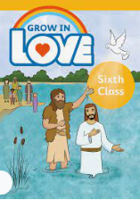
Senior Infants: Grow in Love

First Class : Grow in Love

Second Class: Grow in Love

Third Class: Grow in Love

Fourth Class: Grow in Love

Fifth Class: Grow in Love

Sixth Class: Grow in Love

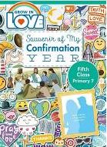
Additional resources being used:
Journey to Confirmation, , Advent and Lenten Diocesan Resources, Catholic School Week Resources, Sacramental Workbooks, Souvenir of My Confirmation Year.


- In order to better help parents understand what their children are learning in religious education children a link with home is made on a weekly basis in each class.

This is done by class teachers.

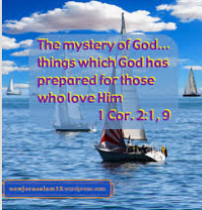
- Children have an understanding and knowledge of their Christian faith through exploring the mystery of God, Jesus, the Holy Spirit and the Church/kingdom, through learning about creation, Mary, Eternal Life and other Religious Traditions and as indicated by the curriculum in Level 1 page 52 -54, Level 2 page 66-67, Level 3 page 84-88 and Level 4 page 106 -113.
- Each senior classroom has access to a set of bibles.

- Children are familiar with bible stories, have an understanding and knowledge of Sacred Scripture, study the structure of the bible, know that Sacred Scripture is the revealed Word of God as indicated by the curriculum in Level 1 page 55, Level 2 page 71, Level 3 page 89 and Level 4 page 115-116.

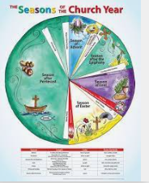
- Children have an understanding and knowledge of the liturgical life of the Church, the structure of the Mass, the seasons of the liturgical year, the way in which we meet Jesus in liturgy, sacraments and prayer, the seven sacraments of the Church as indicated in Level 1 page 58-80, Level 2 page 73-77, Level 3 page 93-99 and Level 4 page 119-125.

- Children have an understanding and knowledge of human dignity, Church social teaching, RSE in a Christian context, the two-fold commandment and the ten commandments, they know that following Jesus is living according to Gospel values, that the Christian moral life is an expression and consequence of relationship with God as indicated by the curriculum in Level 1 page 42, Level 2 page 78-80, Level 3 page 100 -102 and Level 4 page 126-130
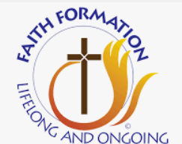
- The faith formation dimension which forms the children’s characters in the virtues and values of Jesus, supports their faith development and helps them to experience what it means to be a member of the Church is recognised and supported as an integral part of religious education. The faith formation goals in the curriculum p 134-143 support and reflect this dimension.
- Attention is given to integration of religious education across the primary school curriculum. St John Paul II gave expression to this when he stated that religious education will always seek to ‘keep in touch with the pupil’s knowledge and education; thus the gospel will impregnate the mentality of the student in the field of their learning and the harmonization of their culture will be achieved in the light of their faith.

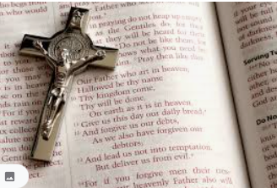
- Children are provided with opportunities to learn by heart traditional prayers, Mass responses, hymns, biblical texts, faith words and faith summaries as outlined in the programme of religious education in use in the classroom.

- Provision for Religious Education is made for children with Special Educational Needs as indicated by the Special Education Curriculum Guidelines page 146-154.

Sacramental Preparation and Celebration
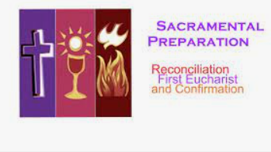
General
- Leadership in the school make a conscious effort to ensure that teachers in sacramental classes are faith filled witnesses to the Christian life.
- Children are prepared for the sacraments of Reconciliation, Holy Communion and Confirmation in partnership with parents and parish.
- It is understood that children’s understanding of these sacraments develops throughout their time in primary school and beyond.
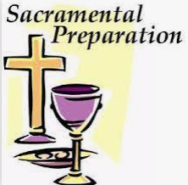
- The school supports the ongoing conversation at parish and diocesan level about how best to prepare for and celebrate the sacraments of Reconciliation, Holy Communion and Confirmation
- The school works together with parents and parish to ensure that sacramental celebrations are authentic, sacred encounters with Jesus Christ
- Practice for sacramental celebrations are confined to no more than two hours of school time.

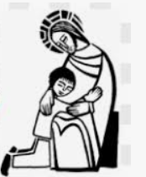
Celebrating Reconciliation for the First Time
- The celebration takes place in the local parish church preferably during the Lenten season.

- Parents and other family members are invited to celebrate the sacrament with their children

Celebrating Holy Communion for the First Time
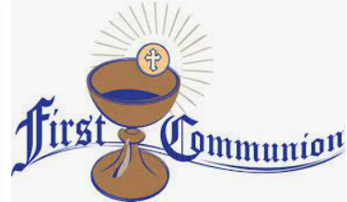

- Consideration is given to celebrating Holy Communion during a Sunday mass

- There is a separate/special Mass for the First Communicants

- Children sit with their parents/families

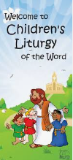

The children are involved in all aspects of the liturgy on the day, e.g. readings, prayers of the Faithful, Offertory Procession, etc.

Parish-led preparation for the sacrament is offered.
The programme or process which is being actively developed in the parish is :

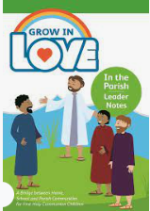
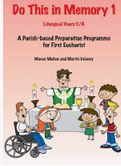
- Grow in love

- In the Parish programme (A Bridge between Home, School and parish communities for First Holy Communion Children

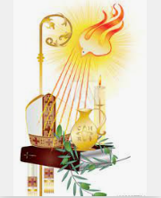
The Sacramernt of Confirmation

- Teachers of Confirmation classes are aware of the Diocesan Guidelines for Confirmation and together with school and parish leadership ensure that these guidelines are followed.

- MAYBE-----Children are encouraged to write their letter to the bishop telling him why they would like to be confirmed.


- MAYBE----Children preparing for Confirmation are offered a retreat experience either before or after celebrating the sacrament.

- MAYBE----Parish led preparation for the sacrament is offered. The programme or process in place is You shall be my Witnesses or _________________________________________________________________________________________________________________________________________.

Partnership in Religious Education
Home
- The school seeks to involve parents in their children’s religious education


  - Making a link with home in religious education every week/month.

  - Encouraging parents to have a prayer space at home.

  - Ensuring parents know which prayers their children are learning and encouraging them to pray with their children at home.

  - Inviting parents to attend prayer services, assemblies Mass and other religious celebrations
Parish
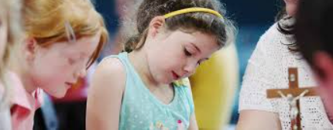
- Relationships between school and parish leadership are fostered and encouraged.

- The school Principal/ RE Co-Ordinator meets and discusses with the priests/parish team member responsible at the beginning of each term to plan for visitation of classrooms, visits to the church, celebration of Feast Days, key liturgical celebrations in the school calendar, sacramental preparation and celebration.

- The school supports the parish in offering parish led preparation for sacraments, e.g. the children are involved in a weekend celebration of the Eucharist, (perhaps, once a term, once a month, etc.)

Inclusion of Pupils of Different Faiths

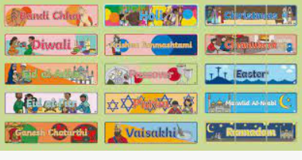
Children of all faiths and none are welcome in our school. Our school is hospitable, open and inclusive. We continuously strive for best practice concerning the inclusion of pupils in our school. Our practice is founded on principles of good communication, clarity on rights and responsibilities, right relationships, openness to dialogue and compromise and flexibility.
- Our Admissions Policy and Mission Statement makes clear that we are a Catholic School under the patronage of the local Catholic bishop.

- It is clear to parents enrolling their children that the Catholic ethos of our school permeates the whole school day and not just the formal religious education class.

- Our Admissions Policy makes clear that we welcome diversity and inclusion and that we believe that the presence of children from diverse backgrounds enhance and enrich our school community.

PRE-ENROLMENT Meeting

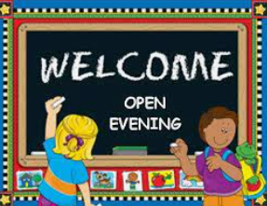
- A pre-enrolment meeting (open day) is held at which issues relating to ethos and formal religious education are discussed with prospective parents.

- Parents are aware that there are prayers at assemblies, and at moments during the school day. It is made clear that for children of other faiths and different stances for living that these can be times for personal reflection.

- Parents are given an understanding of the nature of religious education in the Catholic Primary School. (An example of what this might look like is available in Catholic Primary Schools in a Changing Ireland, p25).

- Parents who have concerns about the content of the religious education programme are invited to meet with the principal/teacher/religious coordinator

Opt out

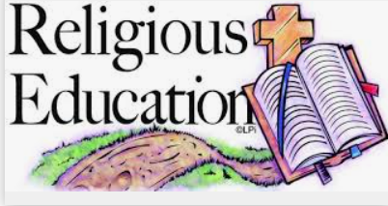
- If parents wish to have their children opt out of formal religious education, the school offers some or all of the following options:

  - If alternative supervision is not possible, staying within the classroom and engaging in an educationally appropriate activity.

  - Split timetabling of religious education across class streams.

  - Supervised educational activity where a staff member is available.

  - Withdrawal by parent of child for the purpose of receiving religious instruction elsewhere.

Ongoing Communication, Opportunities for Inclusion and Parental Choice

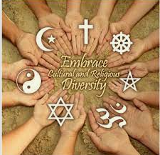
- Parents whose children are of other faiths or different stances for living are made aware in advance of any religious events or celebrations.

- Children are always invited but not obliged to attend all Catholic religious celebrations in the school.

- Individual children, with parental consent, may wish to participate in these celebrations by reading appropriate prayers and texts, participating in art or drama, being part of the choir, playing an instrument etc.

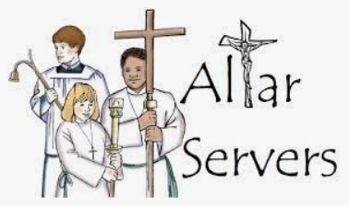
- Children with the consent of their parents are given the opportunity to serve at Masses, as agreed with the parish team.

- Parents are free to absent their child from school for the duration of these events.

- Consideration is given to the timing of these events.

- Care is taken that the time allotted to religious education is not exceeded during times of sacramental preparation.
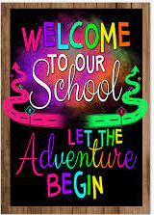
- Notice boards and school displays are used to make pupils feel welcome.

- Celebrations of the different cultures present in the school are scheduled.

- Reconciliation is a feature of daily life. Staff and children are encouraged to grow in appreciation of human dignity.

- School assemblies acknowledge festivals associated with the other faith traditions present in the school.
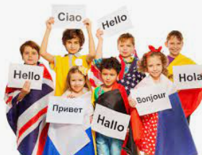
- Children of different faiths are given the opportunity to explain their beliefs to other children.

- Key materials are translated as resources allow.

Some Useful Texts
Catholic Preschool and Primary Religious Education Curriculum for Ireland (Veritas: Irish Episcopal Conference, 2015)

Share the Good News: National Directory for Catechesis in Ireland (Veritas: Irish Episcopal Conference, 2010)

The Irish Catholic Catechism for Adults (Veritas: Irish Episcopal Conference, 2014)

Catholic Schools in a Changing Ireland: Sharing Good Practice on Inclusion of All Pupils (Catholic Schools Partnership: 2015)

Governance Manual for Primary Schools 2015-2019

Catholic Pre-School and Primary Religious Education Curriculum for Ireland page 31
Catholic Pre-School and Primary Religious Education Curriculum for Ireland page 12
The Certificate in Religious Studies
The following bibles are most appropriate for use in the primary classroom: The Good News Bible, New Revised Standard Version, The Catholic Children’s Bible, (St. Mary’s Press), The Contemporary English Version
Catechesi Tradendae 60
Forum on Patronage and Pluralism in the Primary Sector: Progress to Date and Future Directions, p19

